Section: Create Campaign
Module : Setup Campaign in My Hometown


Setup campaign in my hometown
“In this module we show you how to setup new campaign, especially in your hometown.”
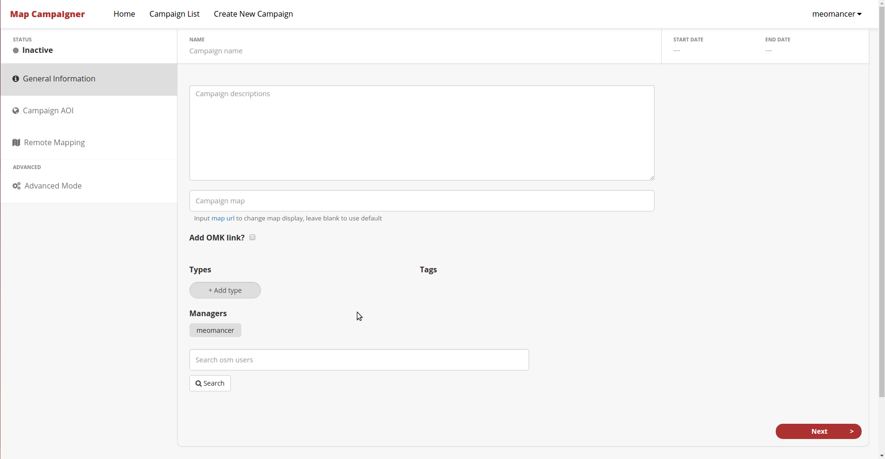
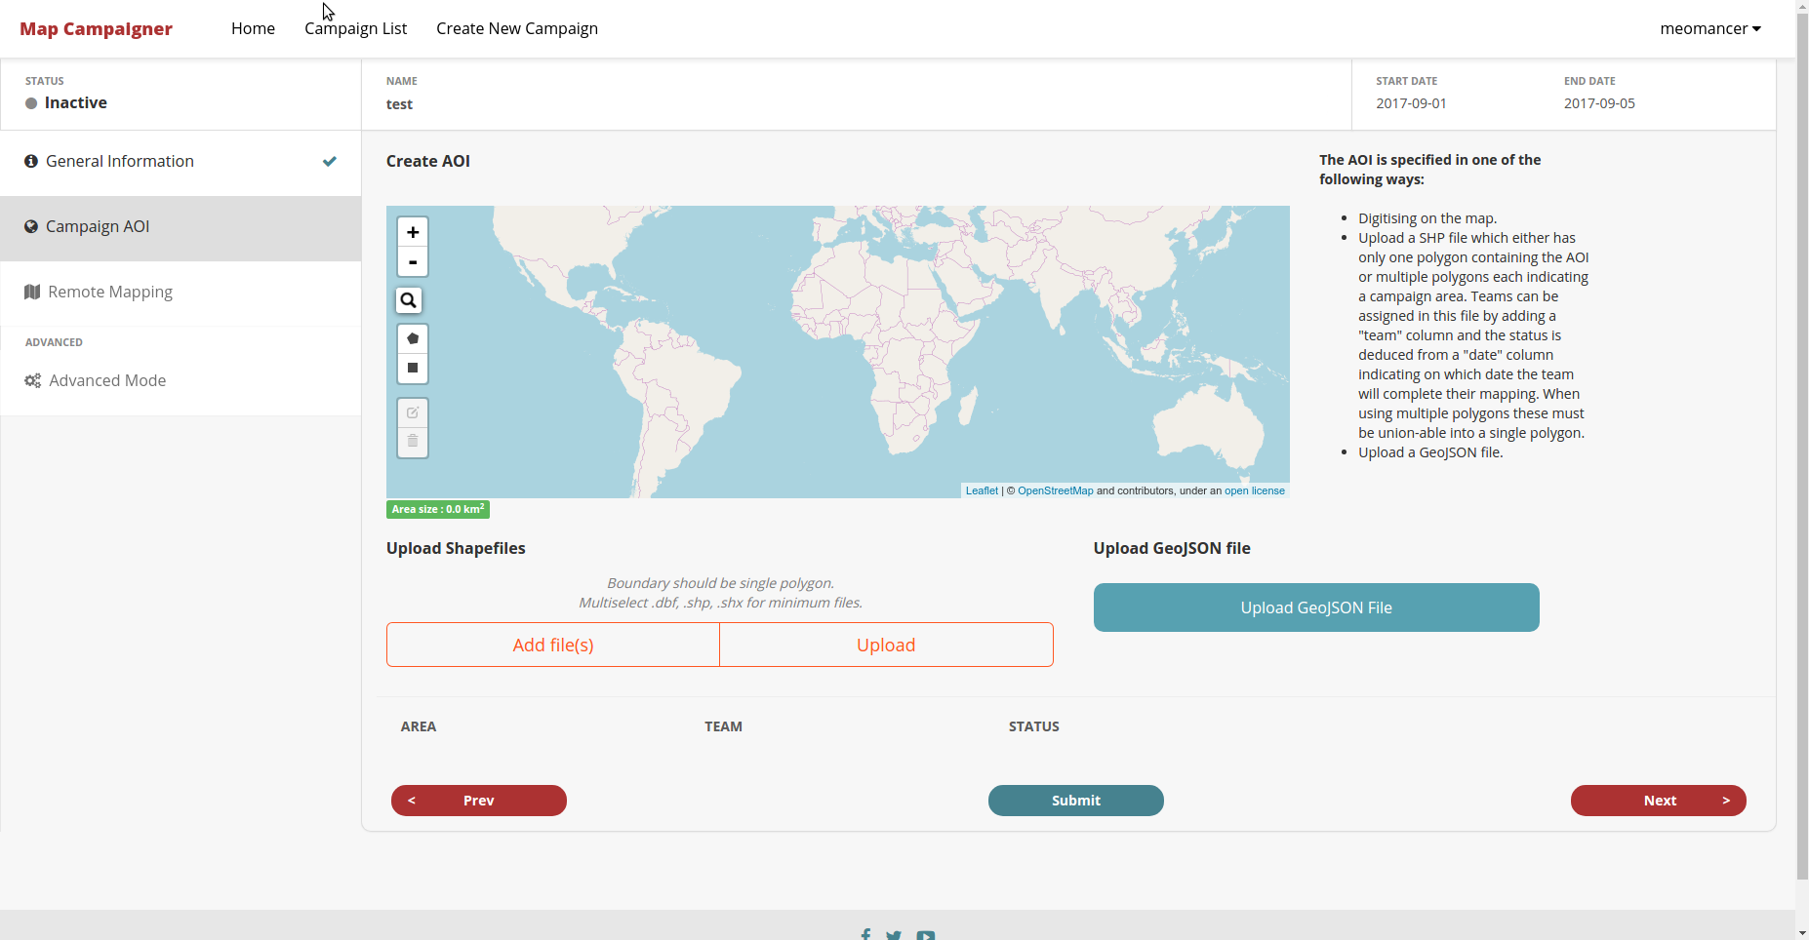
In create campaign, there are 2 steps that needs to be done before we can save it. First is General information, which contains general information for campaign. Second is Campaign AOI, which is section to draw the area of campaign that we need for.


You try:
Goal: Set up campaign in your hometown.

* Login to field campaigner and go to “Create New Campaign” in top navigation.

* Fill general information for new campaign. On types section for now just add type and select “buildings”.
* On Campaign AOI, let's try find yout hometown by clicking magnifying glass icon on the map and search your hometown.
* After map go to your hometoen, let's try to create campaign AOI, around in hometown by clicking pentagon shape or rectangle shape and draw in map.
* Click “General Information” tab or “Campaign AOI” tab for overview your changes between.
* Don’t forget to submit your changes if you are satisfied.

Check your results:
- Return to home, can you see your new campaign on the list?
- Click your campaign to go to detail. Could you see the polygon on the map based on your last created campaign AOI?
Name | Value
Area of Interest | Zoom in to your hometown.
Type | 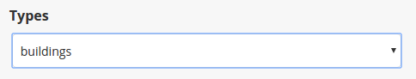
Draw | The campaign AOI, finish your polygon by clicking again on your start point.
Validate | 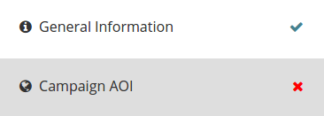  Validate with looking tick for each tab.
Submit | Submit changes with  


More about
As overview before, we have 2 steps that needs to be done. On each of step, there are also input that needs to be filled to. The input will be indicated by error if the it is not filled.
For campaign AOI, there is limitation of how big is the AOI that we create. There will be indicator for everytime we finish creating polygon.

Check your knowledge:
- How many inputs that required in General Information?
- 3
- 4
- 5
- 6

- When “END DATE” input is before than today, what happened?

- Is vatican allowed to be as campaign AOI?
- Yes
- No

Further reading:

